**Computer Graphics – CS - 5472**

**Project #3:**

3D Tree:

**Student Names:**

Lang Wu (0648304)

Harsh Joshi (0665005)

**Emails:**

lwu5@lakeheadu.ca

hjoshi@lakeheadu.ca

Professor: Dr. Maurice W. Benson

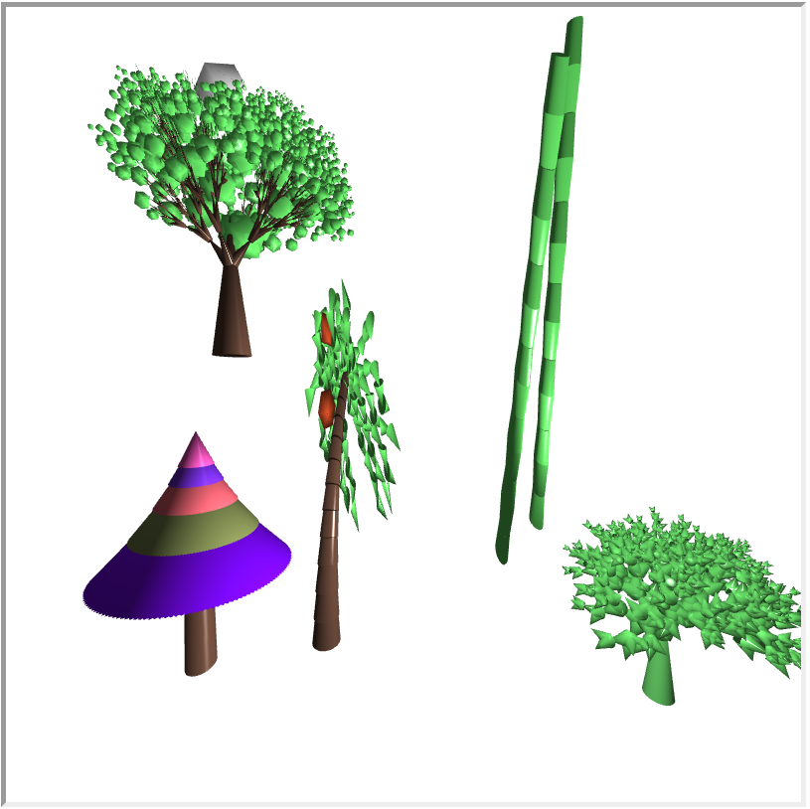

1. There are five types trees we have made.

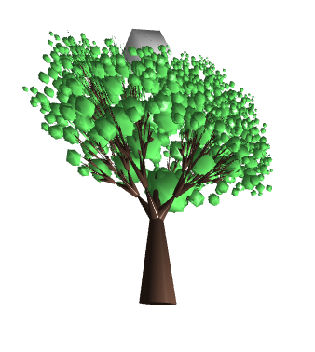

2. gray polygon which is behind the tree is sun with the same position of light source. Trunk and branchs are drawing by cones recursively. Leafs are polygonal and using the same way as we draw a sphere but reduce the number of longtitute and latitute so that is looks more like a polygon.

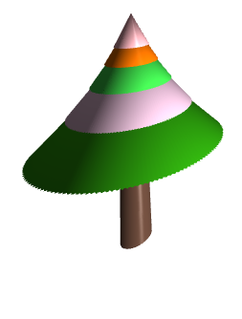

3. christmas tree is drawing by many cones except for the trunk, which is by cylindar.

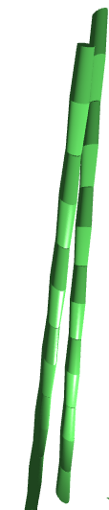

4. bamboo is drawed by cylindars.

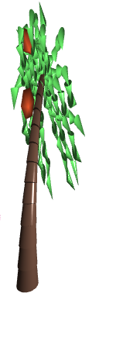

5. leaf are drawed recursively by cones. Trunk is done by cylindar and fluits are polygonal.

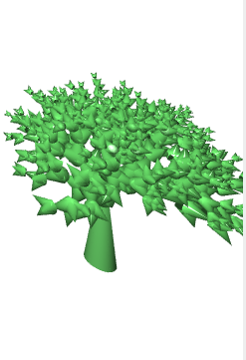

6. the super simple tree is done by recursively drawing cones and scale and change the direction for different levels.

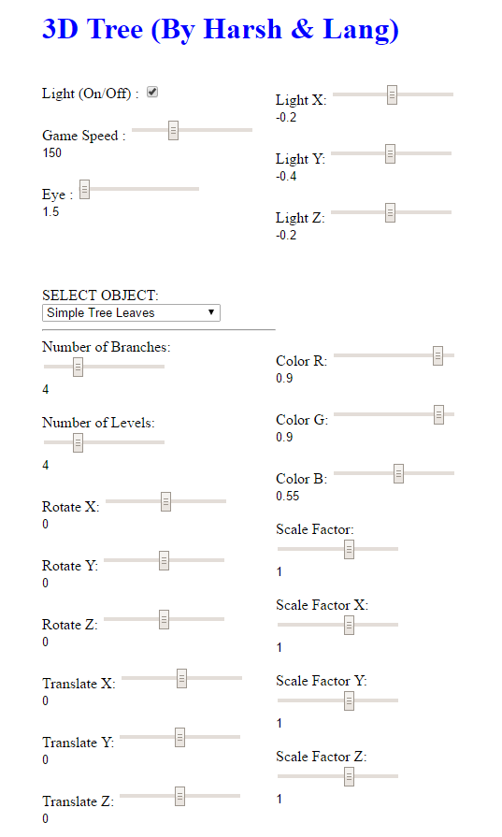

7. user interactions.

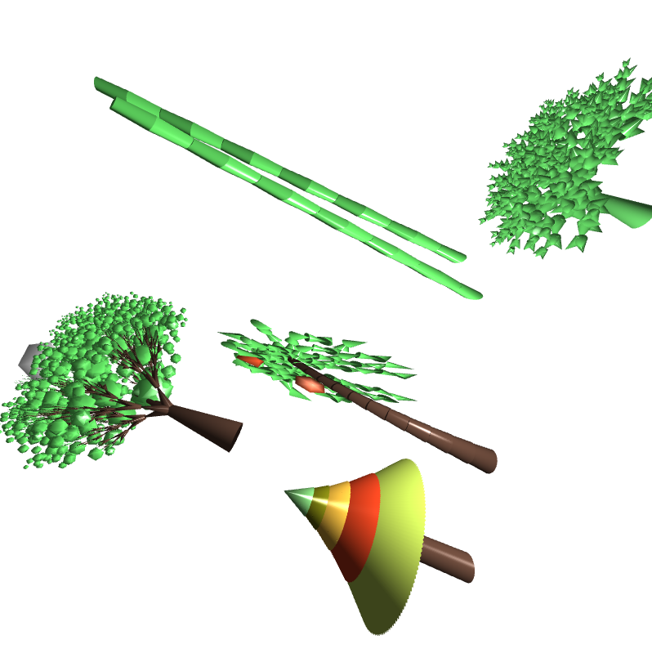

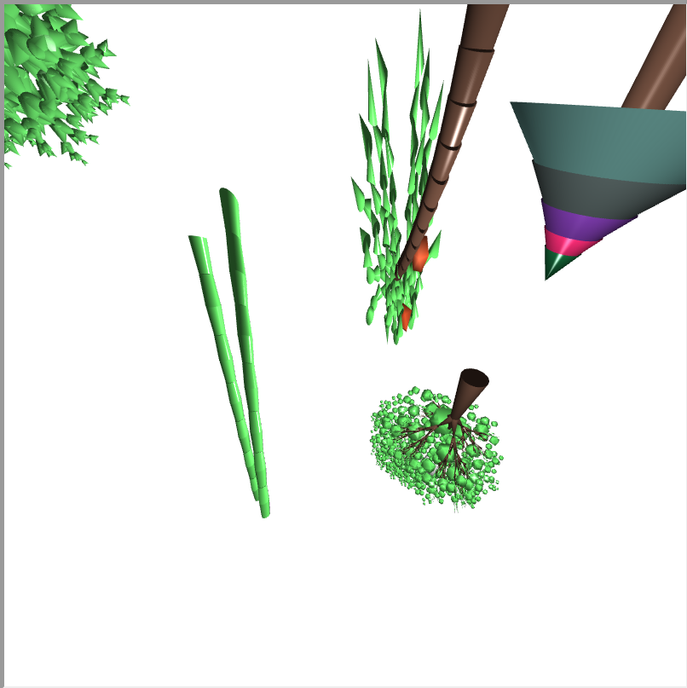

8. rotation is working .

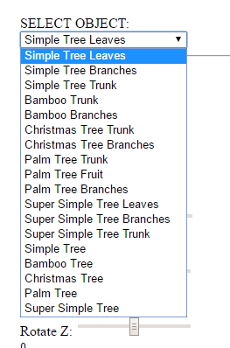

9. by selecting different object on the screen users can apply different changes on them.